**HTML**

* Hyper Text Mark UP language
* For creating web pages
* Static language for for front end desining /design construct
* Web site design only
* For Dynamic-programming language
* Editors:notpad,dreamweaver,vs
* .html extension
* Default browser iconil kanam
* Html elements describe how to display the content
* Elements are defined by a tag
* Start tage some content End tag
* <tag name> content</tag name>
* Html page structure

<!DOCType html>

Document is an html 5 document

<html>

Root element of HTML page

<head>

Container for meta data (data about html document) meta data is not dislaped

<title>

Inside head tag

Page title usually written inside title tag(title baril display avum)

<body>

Visible part of html document is between <body> and </body>

Container for visible content such as heading paragraph images and links tables lists ect

* Heading tag

<h1> to <h6> bold size large

<h1> most important heading

<h6> least important heading

* Paragraph

<p> tag to define para graph

*The <p> tag is both presentational and semantic. It defines paragraphs in HTML. Anything written within <p> and </p> is treated as paragraph. The browser automatically adds space (a single blank line) before and after each <p> element, which is simply margins added by the browser*

* *<hr>*

*Horizontal rules ,used to separate contentment I n html page*

* line break

<br>defines a line break

* Attributes

*Attributes provide****additional information****about elements*

Attributes are always specified in **the start tag**

*Attributes usually come in name/value pairs like:****name="value"***

* Links

<a href=<http://jkdcdlc>>this is alink</a> //links destination is specified in the href attribute

* Image tag

<img src=”aa.jpg” alt=”w3school.com” width=”104” height=”142”>

*alt attribute for the <img> tag specifies an alternate text for an image*

* Style Attribute

*The HTML style attribute is used to add styles to an element, such as color, font, size, and more*

<tagname style="property:value;">

<body style="background-color:powderblue;">  
<h1>This is a heading</h1>  
<p>This is a paragraph.</p>  
</body>*.*

<body>  
<h1 style="background-color:powderblue;">This is a heading</h1>  
<p style="background-color:tomato;">This is a paragraph.</p>  
</body>

<h1 style="color:blue;">This is a heading</h1>  
<p style="color:red;">This is a paragraph.</p>

<h1 style="font-family:verdana;">This is a heading</h1>  
<p style="font-family:courier;">This is a paragraph.</p>

* Formatting elements

Formatting elements were designed to display a special type of text

* <b> - Bold text
* <strong> - Important text
* <i> - Italic text
* <em> - Emphasized text
* <mark> - Marked text
* <small> - Smaller text
* <del> - Deleted text
* <ins> - Inserted text
* <sub> - Subscript text
* <sup> - Superscript text

<b>This text is bold</b>

<p>This is <sub>subscripted</sub> text.</p>

<p>WWF's goal is to: <q>Build a future where people live in harmony with nature.</q></p>

<p>The <abbr title="World Health Organization">WHO</abbr> was founded in 1948.</p>

## HTML Comment Tag

You can add comments to your HTML source by using the following syntax:

<!-- Write your comments here -->

# **HTML Lists**

## Unordered HTML List

An unordered list starts with the <ul> tag. Each list item starts with the <li> tag.

The list items will be marked with bullets (small black circles) by default:

<ul>  
  <li>Coffee</li>  
  <li>Tea</li>  
  <li>Milk</li>  
</ul>

## Ordered HTML List

An ordered list starts with the <ol> tag. Each list item starts with the <li> tag.

The list items will be marked with numbers by default:

<ol>  
  <li>Coffee</li>  
  <li>Tea</li>  
  <li>Milk</li>  
</ol>

## HTML Description Lists

HTML also supports description lists.

A description list is a list of terms, with a description of each term.

The <dl> tag defines the description list, the <dt> tag defines the term (name), and the <dd> tag describes each term:

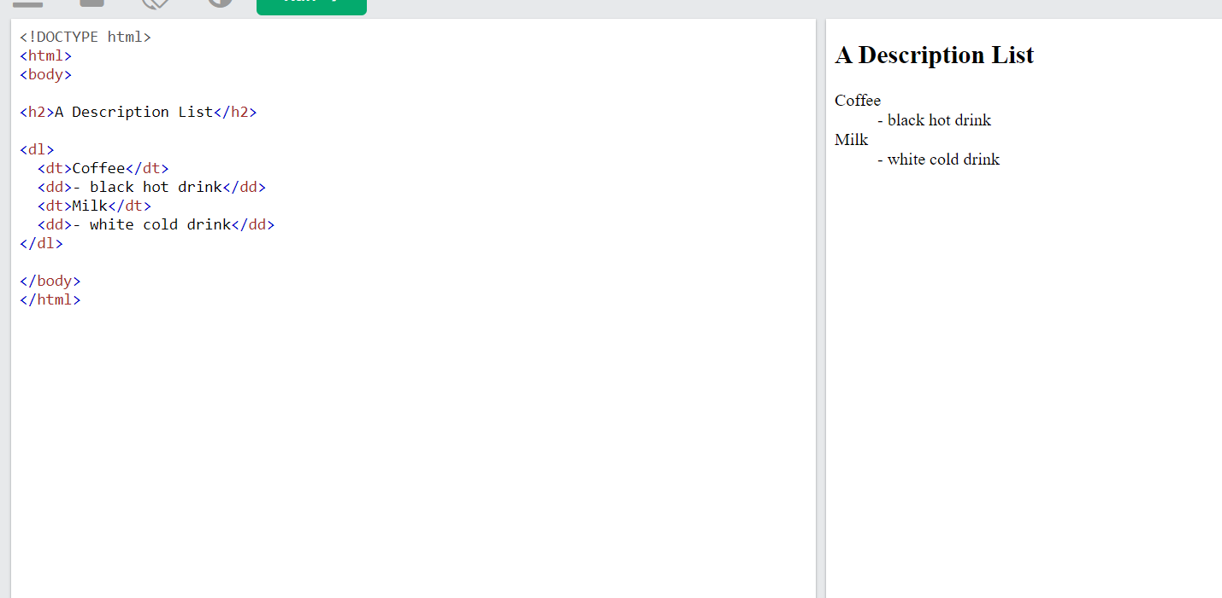

**Table**

HTML tables allow web developers to arrange data into rows and columns.

## Table Cells

Each table cell is defined by a <td> and a </td> tag.

## Table Rows

Each table row starts with a <tr> and ends with a </tr> tag

## Table Headers

Sometimes you want your cells to be table header cells. In those cases use the <th> tag instead of the <td> tag:

th stands for table header.

**FORM**

An HTML form is used to collect user input. The user input is most often sent to a server for processing

<form>  
  
*form elements*  
  
</form>

The <form> element is a container for different types of input elements, such as: text fields, checkboxes, radio buttons, submit buttons, etc.

## The <input> Element

The HTML <input> element is the most used form element.

An <input> element can be displayed in many ways, depending on the type attribute.

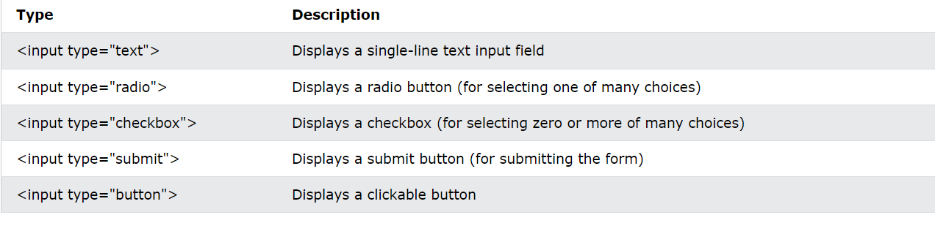

## The <label> Element

The <label> element defines a label for several form elements.

The <label> element is useful for screen-reader users,

## The <select> Element

The <select> element defines a drop-down list:

The <option> element defines an option that can be selected.

By default, the first item in the drop-down list is selected.

## The <textarea> Element

The <textarea> element defines a multi-line input field (a text area):

<textarea name="message" rows="10" cols="30">  
The cat was playing in the garden.  
</textarea>

**Form attribute**

## The Action Attribute

The action attribute defines the action to be performed when the form is submitted.

Usually, the form data is sent to a file on the server when the user clicks on the submit button.